Emily A. Wade

HCDD 113

# L04: Design Activity – Low-Fidelity Prototype Title: Create a Low-Fidelity Prototype

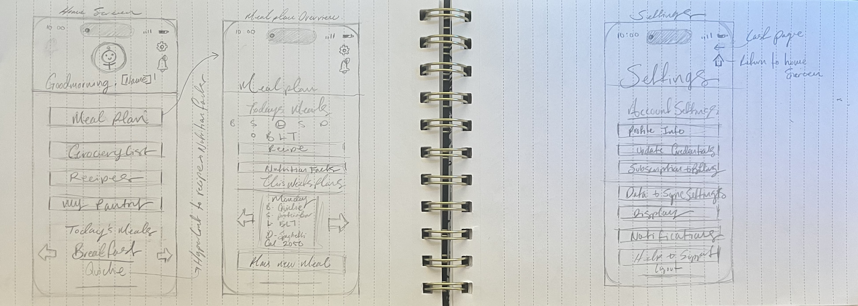

My prototype is of an app for meal planning and tracking. I asked my husband, Nicco Wade, to walk through the process of creating a new meal plan and to change his display to dark-mode. Nicco was able to easily locate where the tab to create a new meal plan was and where to find the correct settings for display. He liked where the settings was located and as well as the option to return to the previous screen or home on the settings tab. However, he suggested adding a dedicated screen for meal planning to show what happens when users create a new meal. Additionally, he found the Settings screen cluttered and recommended a clearer organization with distinct sections.